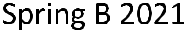



Darek Konopka




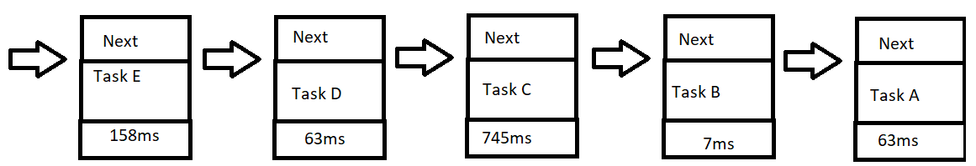

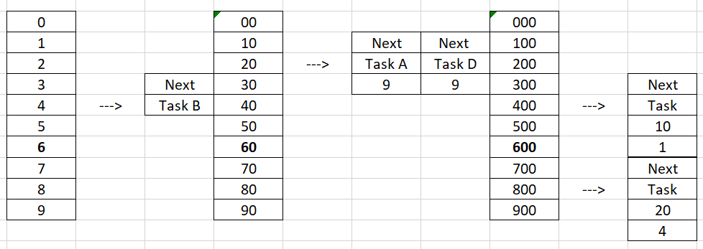

Ignore the green markings on the 0’s, it is an excel thing to do that to boxes with more than one 0.

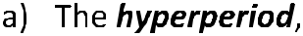
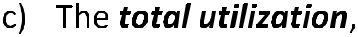
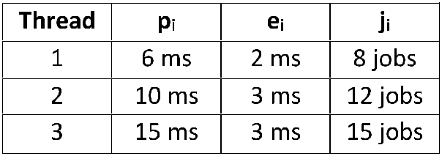

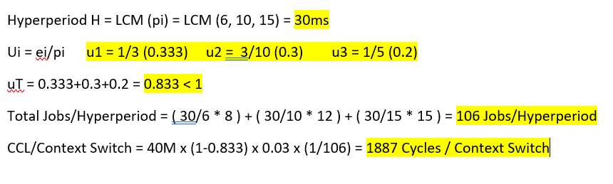

(Reminder for cycles/context switch calculation 0.833 was actually 0.8333.. repeating since we had u1=1/3)

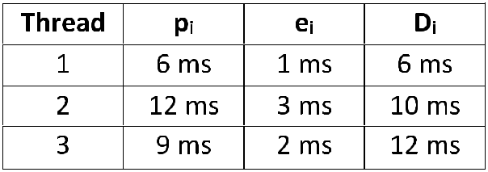

- Hyperperiod H = LCM (pi) = LCM (6, 12, 9) = 36ms
- Constraint 1: f >= 3
Constraint 2: T1 = 1, 2, 3, 6 T2 = 1, 2, 3, 4, 6, 12 T3 = 1, 3, 9
Constraint 3:

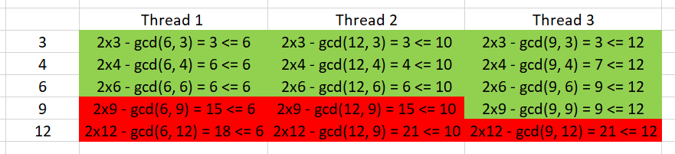

The valid frames are 3, 4, 6


